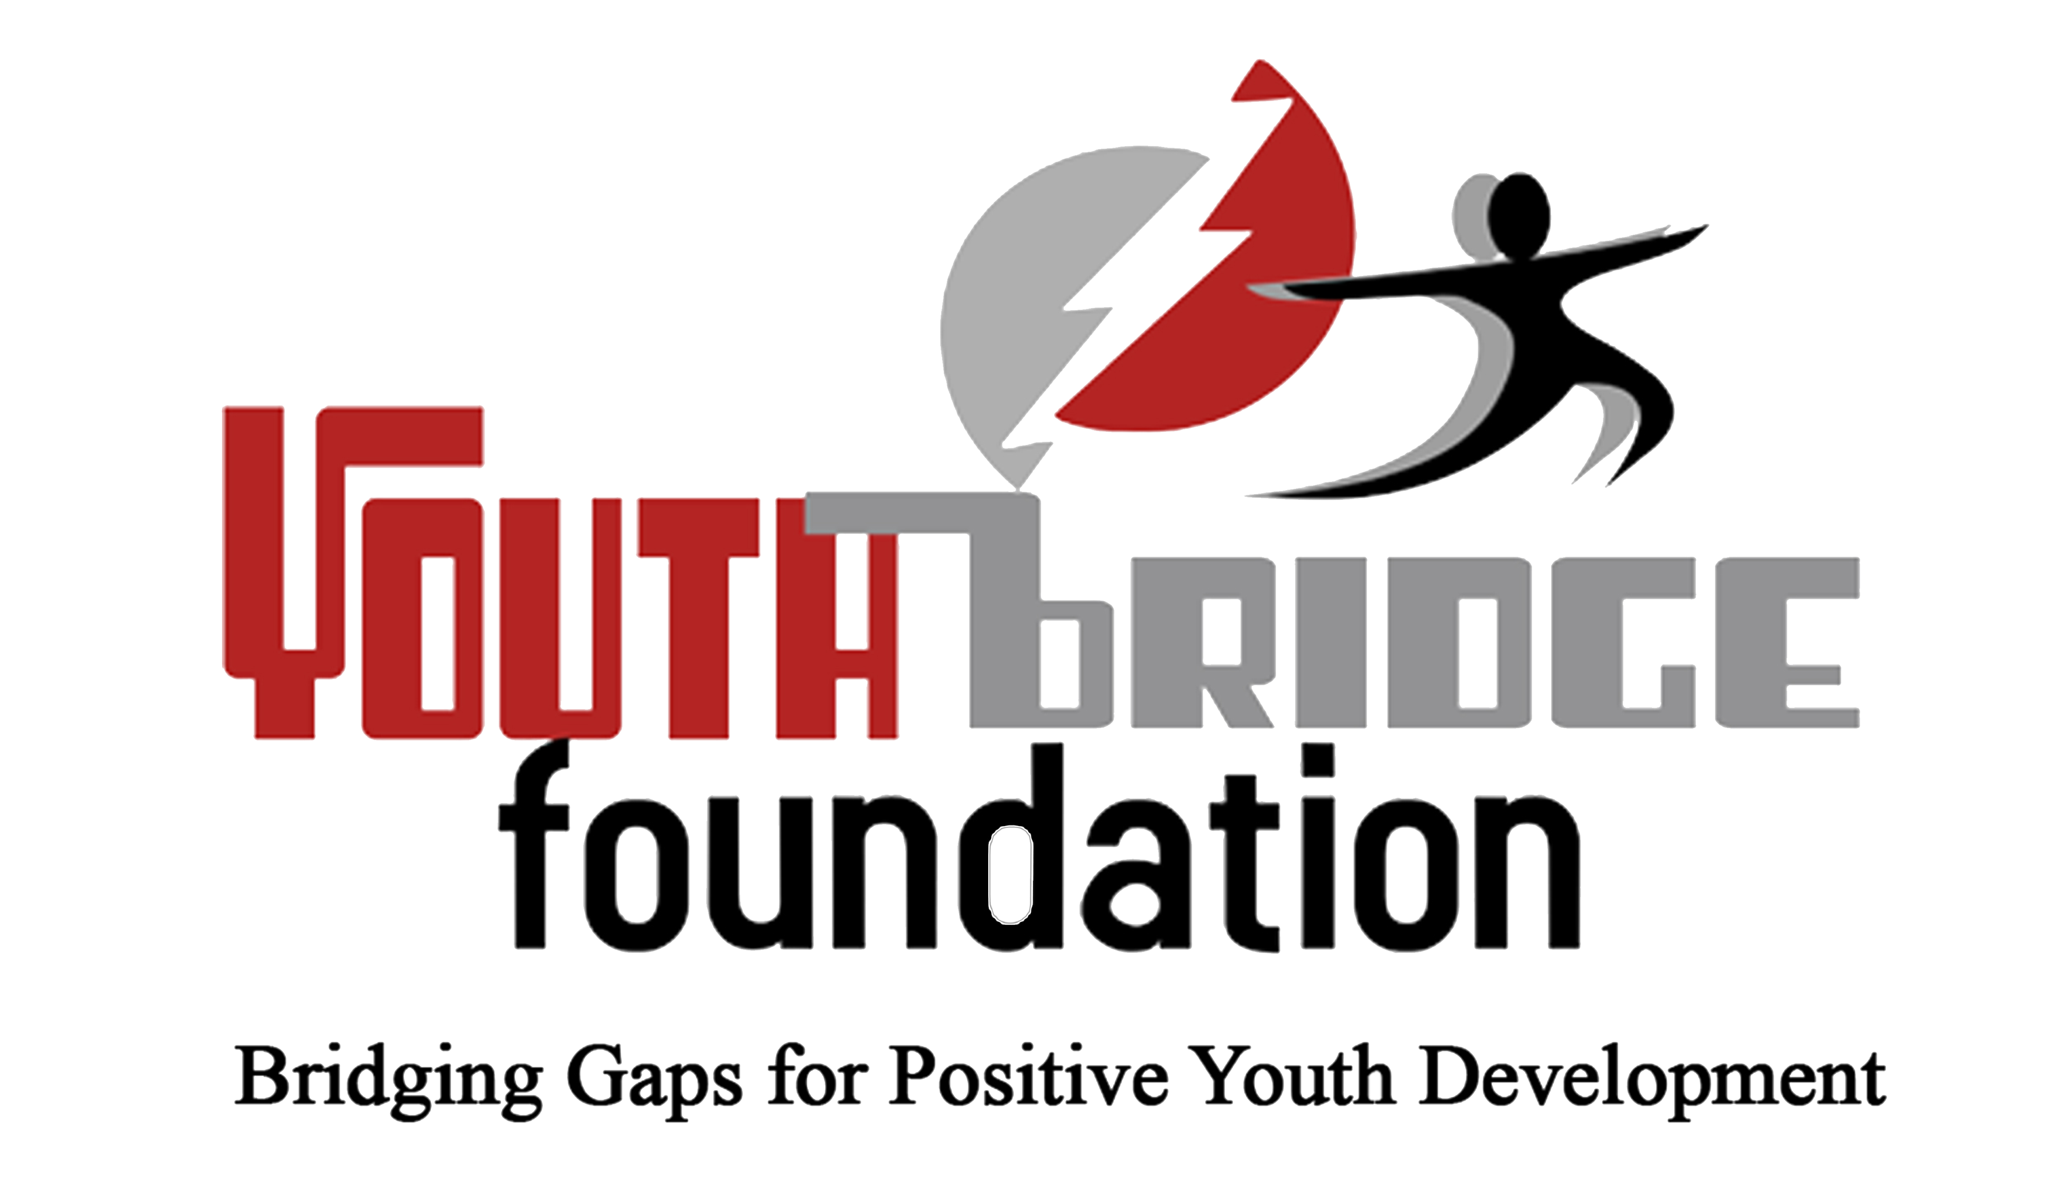

  
  
**Press Statement on the Commemoration of International Day of Sign Language (IDSL)**  
  
For Immediate Release  
1. The Youth Bridge Foundation (YBF), a youth development organization committed to the promotion of equitable and inclusive society wishes to commend all organizations that endeavor to use sign language as an additional communication tool, on the occasion of the International Day of Sign Languages (IDSL).   
2. We wish to issue an Action Alert to the government of Ghana to improve the quality of life of hearing impaired youth and indeed, all other Ghanaians, by developing and implementing a proactive policy that ensures that people with hearing impairments are not left out in communication.

3. We believe that, improving the quality of life for the hearing impaired cannot and must no longer be postponed as the nation strives to attain the goal 16 of the Sustainable Development Goals, which inter alia, states the need to “...promote peaceful and inclusive societies for sustainable development...”  
4. Inspired by this year’s theme: "Sign Language Rights for All!" and the need to achieve Goal 16 of the SDGs, we further make the following calls:   
A. Government, through the Ministry of Gender, Children and Social Protection (MoGCSP), must sponsor a bill that makes it a requirement for Ministries, Department and Agencies as well as Metropolitan, Municipal District Assemblies (MMDAs) to have sign language interpretation facilities in place. This should facilitate communication of hearing impaired citizens who have equal rights to their services.

B. Government must consciously address the barriers to the academic progression of hearing impaired youth to secondary and tertiary educational institutions.  
C. Government must create more space and expand the existing training opportunities for sign language interpreters in Ghana.  
D. The National Media Commission (NMC) should ensure the introduction and enforcement of sign language interpretation on all television programmes.  
E. Private institutions such as banks and transport yards must provide sign language interpretation facilities to help improve the quality of services rendered to the youth and all hearing impaired citizens.

F. The International community and Development Partners should endeavor to support initiatives that seek to bring People with Disabilities (PWDs) including the hearing impaired citizens into various public discourse.  
G. The youth and all Ghanaians must treat hearing impaired citizens and all PWDs with love, respect and tolerance. As a people, we must all make the effort to learn sign language to support the integration of hearing impaired youth into the society and improve their quality of life.

**We recognize with high commendation the following efforts:**

1. Parliament for integrating sign language into parliamentary proceedings in 2018.  
  
2. Open Society Initiative for West Africa (OSIWA) for financing YBF's production of PUZZLED, a 13-episode Drama Series on Child and Family Welfare Policy with the integration of sign language in each episode.  
  
3. Selected TV stations for integrating sign language interpretation into specific news bulletins.   
  
We wish all the youth and Ghanaians with hearing impairments, a happy IDSL day.

SIGNED  
**Seth Oteng (Mr)  
Executive Director**   
**Dated: September 23, 2019**  
Contact  
TEL.: 0243229505