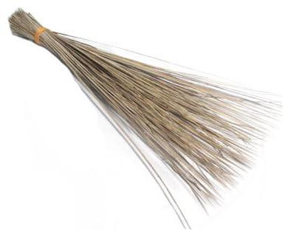
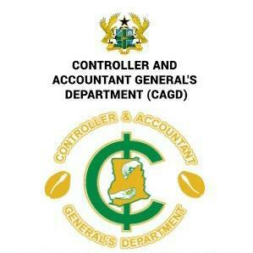
CONCERNED CAGD STAFF

Tel: 0208289005
Email: concernedcagd@gmail.com

In case of reply, the reference number
and date must be quoted.
Our Ref:
Your Ref: …………………… Date: 10th January,2023

THE CAGD MANAGEMENT
TREASURY HEADQUARTERS
ACCRA
Through:
THE REGIONAL DIRECTOR
CAGD, NORTH EAST REGION
Sir,
PETITION TO THE MANAGEMENT OF CAGD AND THE MINISTRY OF FINANCE (MoF), ACCRA.
Having been denied our 2021 honorarium for the first time in the history of CAGD, we the concerned staff of CAGD wish to unequivocally state that any attempts by the Management of CAGD and the Ministry of Finance (MoF) to once again deny our hardworking staff of this age-old ‘solace’ would not be tolerated. Staff would be left with no option than to embark on series of legitimate actions, including abstaining from the upcoming national accounts validations exercise and the GoG monthly salary validations, to get this allowance paid us.
We are by this petition, serving notice to the CAGD Management and the MoF to, as a matter of urgency, get this matter addressed or we advise ourselves.
All staff of the sixteen Regions of Ghana are on this date, presenting this letter to our Management and the MoF through the Regional Directors of CAGD, calling on CAGD and MoF to do the needful by paying the two years (2021 & 2022) honorarium with immediate effect to avoid the repercussions of our intended actions.
Thank you.

SIGNED
Concerned Staff of CAGD

