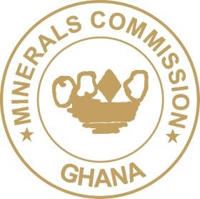
MINERALS COMMISSION

PRESS STATEMENT
RE: PIEDMONT COMMITS TO FUNDING ATLANTIC LITHIUM’S GHANA PROJECT
The attention of the Minerals Commission (the “Commission”) has been drawn to a news release by Piedmont Lithium (“Piedmont” or the “Company”) in respect of the company’s acquisition of a stake in the Ewoyaa Lithium Project in Ghana.
The Commission wishes to inform the public that Cabinet on 27 July 2023 approved a new policy framework for the exploitation, management and regulation of lithium and other green minerals in Ghana. The overarching goal of the new framework is anchored on the principle that the exploitation of green minerals including lithium must benefit Ghanaians who are the true owners of the mineral resources.
In this regard, negotiations are ongoing with Atlantic Lithium Limited on the development of the Ewoyaa Lithium deposits in the Mfantseman Municipality of the Central Region.
Consequently, the Minister of Lands and Natural Resources has not approved any contract, transaction, deal or stake for any person, company or entity in respect of the Ewoyaa Lithium project.
Additionally, the Commission is by law mandated to make recommendations to the Minister for the grant of mineral rights including a mining lease. The Commission has not made any such recommendation for the grant of a mining lease to the Minister for the development of the lithium deposits at Ewoyaa. At this stage, Atlantic Lithium Limited still holds a prospecting licence in the name of its local subsidiary Barari Development Ghana Limited.
The Commission wishes to remind the media and the public of the commitment of the Government to ensure that that the country reaps optimum benefits from the exploitation of lithium and other green minerals.
SIGNED
MARTIN KWAKU AYISI
CHIEF EXECUTIVE OFFICER

