FAX: 030-227905 wwwnnewpatrioticparty.org
Our Ref. NPP/HQ/PR/2023/09/22//PEC

FOR IMMEDIATE RELEASE
September 22, 2023
GUIDELINES FOR THE NOVEMBER 4 2023 PRESIDENTIAL ELECTION - ISSUED BY THE PRESIDENTIAL ELECTIONS COMMITTEE
The Presidential Elections Committee of the New Patriotic Party (NPP) is pleased to release the Guidelines and Regulations for the forthcoming November 4, 2023, presidential primaries. These guidelines have been formulated after extensive discussions and consultations with various stakeholders, including the presidential aspirants.
DEVELOPMENT
IN
FREEDOM
It is important to note that all the presidential aspirants and the Elections Committee have jointly approved the Guidelines as an acceptable document for the conduct of the November 4, 2023, presidential primaries.
We acknowledge with sincere gratitude the unwavering cooperation from all stakeholders as we pursue an equitable, impartial, and transparent process to elect a presidential candidate for the 2024 general elections.
Thank you.
William Yamoah (Mr

Secretary, Presidential Elections Committee
NEW PATRIOTIC PARTY
(NPP)
GUIDELINES FOR THE NOVEMBER 4, 2023 ELECTION
ISSUED BY THE
PRESIDENTIAL ELECTIONS COMMITTEE
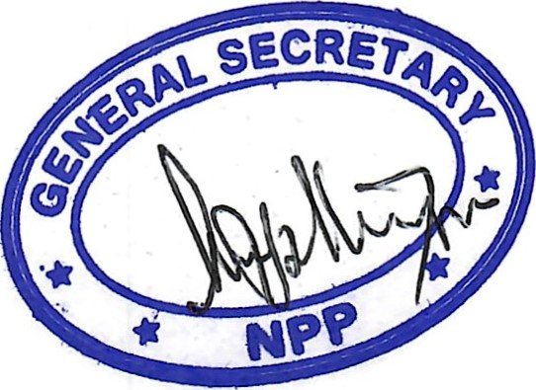
PRESIDEft]TIAL

NEW PATRIOTIC PARTY (NPP) OPERATIONAL GUIDELINES FOR SATURDAY, NOVEMBER 2023, ELECTION

Introduction:
1. These guidelines outline the procedures and rules for the November 4 2023,

Election tc elect a Presidential candidate for the 2()24 general electiono
2. The Electoral Commission of Ghana shall supervise the conduct of the elections and, shall have the full responsibility of ensuring a transparent, free and fair election. No persons, whether government, party official or otherwise whatsoever, shall act in contravention to the Electoral Commission and this guidelines.
30 Security activities rest exclusively with the police and access beyond security perimeters is restricted to Delegates, Presidential Elections Committee Members, Contestants and their accredited agents,
4. The Presidential Elections Committee of the Party is the entity with the Constitutional mandate from National Council to oversee the organization and conduct of the election for the Presidential Candidate,
5, The election will take place on Saturday, November 2023, at all the 276 constituencies Nationwide and the Party Headquarters, Asylum Down, Accra (277 voting centers in ail).
60 In effect, there shall be one Voting Center in each Constituency Capital Nationwide,
- The Electoral Commission shall be mandated to recommend venues as Voting Centers across the country in each Constituency Capital. The proposed Voting Centers shall be discussed and accepted by all stakeholders. In case of disagreement, the Presidential Elections Committee shall decide on the venue.

- A Voting Center can have more than one polling station but on the same premises, depending on the number of delegates. The threshold shall not exceed one thousand (1000) delegates.
- There will be no congregation on the day of voting. Therefore there shall be no provision to address delegates or the public by any Nationai Party Executive, any Government Official, Regional Party executive, Constituency Executives, Contestants or their representatives on the day of the voting.
- There shall be no campaign, canvassing for votes or gathering of party people for any purpose whatsoever a day before voting.
11.There shall be no CAMPING OF DELEGATES.
12.Accreditation is constituency specific.
- The media will be granted accreditation.
- Voters are expected to "walk-in" freely by themselves. The physically challenged may be assisted. A voter must wait to be cleared before entering the perimeter- Queue Control
15.No voter shall wear the colour or effigy of a contestant at the voting center (i.e. T-shirts, cap, posters of contestants).
16.Delegates shall not be allowed to enter the voting screen or booth in groups or in pairs
17. Voting shall not take place indoors but in an open place in the full glare of the public. It is an offence for unaccredited persons to enter the voting perimeter.
18.A delegate who has already cast his/her vote shall not be re-admitted into the voting perimeter.
19.Any person found directing a delegate on which contestant to vote for commits an offence and shall be removed by the police.
20.No contestant will appoint government officials or any delegate listed to vote in the Presidential elections as agents. For the purpose of clarity, such officials include, but are not limited to, MMDCEs, Members of Parliament, Ministers, Deputy Ministers, CEOs of state-owned enterprises, Managing Directors of
Government institutions, Regional Executives, Constituency Executives, Electoral Area Coordinators and Polling Station Executives.
21.ALL VOTERS SHALL LEAVE THE DEMARCATED VOTING PERIMETERS IMMEDIATELY AFTER VOTING.
22.The Electoral Commission and the Police shall enforce and adhere to restricting delegates from taking their phones and other electronic photographic gadgets to the voting screen.
23.Delegates shall not take phones to the voting perimeters and it is an offence to take a picture of any vote or show to any person or to the public how a person has voted. The police shall arrest such a person.
24.Agents of the Contestants are allowed or perrmtted to have their phones.
25.Any vote that had been shown to the public shall be nullified.
- The Electoral Commission shall use complex serial numbers to avoid ballots being traced to voters at a later date.
- The Electoral Commission and the Police shall deny influencers, "Machomen" and undesignated persons access to the voting centers. Ail such persons shall be arrested with dispatch.
- The Electoral voting shall be by a Walk-in standard practice- the indiviciual shall approach the polling area and vote secretly.
- Presiding officers shall not call out names of delegates in the queue to vote.
- Individuals will walk to the officials and they will be assisted to vote accordingly.
- No delegate shall be escorted to the voting screen except those with mobility issues and with Electoral Commission consent.
- Presiding officers shall issue ballots to one delegate at a tune. For the purpose of emphasis, Presiding officers shall not issue ballots to peoole in pairs or groups of persons.
vo Ballot papers should not be torn from any booklet in advance.
vie Both valid and rejected ballots will be securely placed inside the designated ballot boxes and subsequently sealed with seals of the contestants. Hence, no person or official can know how any voter voted. No person will have authority to break the seals for any purpose whatsoever except by an order or the Hign Court.
viia These sealed ballot boxes shall be in safe custody at Electoral Commission for 14 days and if there is no contest from any contestant, the Electoral Commission shall destroy the ballots.

COMPOSITION OF DELEGATES
29.According to the NPP constitution Article 13(1 1 the November 4, Presidential Election shall comprise the following delegates:
i. All members of the National Council iio All voting members of the National Executive Committee iii. All voting members of the Regional Executive Committee ivo All voting members of the Constituency Executive Committees.
v. All Electoral Area Coordinators vio The five (5) Polling Station Executive Officers iti each Polling Station. These are Chairman, Secretary, Organizer, Youth Organizer, and Women Organizer.
vii. Fifteen (15) Members of the National Council of Elders to be elected from amongst themselves viii. Fifteen (15) Patrons to be elected from among themselves ixo All Party Members of Parliament
x. Past National Cfficers xi. Three (3) representatives of each of the special organs of the PartyWomen organizers, Nasara and Youth wingo xiio Twelve (12) delegates from every external branch (27 Branches in all)

comMITTEE
xiii. Founding Members who were signatories to the registration documents of the Party at the Electoral Commission xiv. One (1) TESCON representative from each recognized tenia1Y institution xv. All Party Card bearing Ministers and Deputy Ministers xvi. All MMDCEs
30.Every delegate shall be entitled to one vote and must cast his/her vote for a single contestant.
- To be validly elected, a contestant must obtain more than fifty percent (50%) of the total valid votes cast.
- Where, however, no candidate obtains more than fifty percent (50%) of the total valid votes cast, there shall be a run-off between the first two (2) contestants, and the contestant with simple majority shall be the Party+s Presidential Candidate.

Issue of Tie in the Presidential Election
33.1n the event that two leading contestants obtain the same number of votes but fail to obtain more than 50% threshold, a run-off election will be conducted to resolve the tie. The entire delegates will vote to break the tie.
34.1n the event that one contestant secures the highest number of votes without reaching more than 50% threshold, where two other contestants tie for second place in a situation where the first contestant does not obtain more than 50%, a run-off election will be conducted to determine the winner who shall then contest a run-off to select the final winner. A date shall be set for the same delegate •co vote to select a winner. If a tie shoulci re-occur, a ballot supervised by Electoral Commission shall be conducted.
35. Voting offences shall include the followinu:
- To vote or attempt to vote more than once.
- To buy or sell a vote
- To compel somebody to vote in a particular way
- To obstruct a delegate from freely exercising his or her right to vote
- To display your marked ballot paper.
f, It is an offence to take a photo of how you v oted in any particular way

NPP
COMMITTEE
Proxy Application Process
10 There shall be proxy voting and the opening of proxy applicetion is Monday, October 9, 2023,
Il. The deadline for the submission of proxy application is Friday, October 13, 2023, at 5:00 pm.
111. To successfully file for a proxy, one should show proof of ABSENCE or cause of one's inability to be physically present at the voting center.
- An affidavit or a declaration from a Commissioner of Oath must accompany every application.
- Proxy list will be published for public information and verification.
- Any false affidavit is a criminal offönce and will be repolted to appropriate authorities when a challenge is raised
- Only Delegates to the main Congress who are themselves eligible to vote, shall have the right to vote by proxy.
Vlll. Successful proxy applicants shall have "proxy inscription" affixed on the photos in the Album and the assigned proxy voter would be highlighted.
Voter Register (Album):
- The Party shall generate the Voter Register for the Presidentiai Elections Committee and same shall be submitted to the Electoral Commission and the Presidential Contestants.
Validated Album (Voter Register):
- To ensure utmost transparency and credibility, the Elections Committee shall make the validated Album (voter register) available to all participating contestants no later than Wednesday, October 4, 2023. This provision allows one week for thorough examination and verification of the album before the election date.
38.The following categories of Delegates shall vote at the various Centers as indicated;

a. National Headquarters Centre
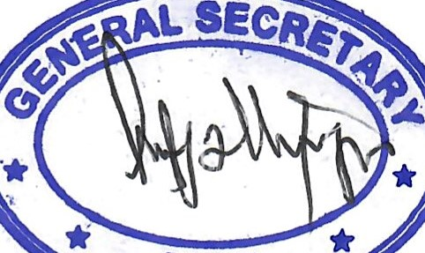
1. National Council and National Executive Committee Members ii. National Council of Elders iii. Patrons iv. Past National Executives
COMMITTEE
v. Sector Ministers and Deputy Ministers who are non-MPs vi. External Branch Delegates vii. Special Wings Delegates

b. 276 Constituency Voting Centres
i. Founding Members ii. Regional Executive Committee Members iii. Members of Parliament iv. Regional Representatives to National Council
v. Regional Ministers vi. All voting members of the Regional Executive Committee vii. All voting members of the Constituency Executive Committees viii. All Electoral Area Coordinators ix. The five (5) Polling Station Executive Officers in each Polling
Station
x. All Party Members of Parliament xi. Founding Members who are signatories to the registration documents of the Party at the Electoral Commission xii. One (1) TESCON representative from each recognized tertiary institution xiii. All MMDCEs
3 9.All Regional Executive Committee members shall cast their votes in a designated constituency within the regional capital,
40. TESCON representatives shall cast their votes in constituencies where their respective institutions are located.
Dispute Resolution:
41 .AII disputes, if any, arising frorn this process shall be referred to the Presidential Elections Committee for prompt and amicable resolution.
42. Persons whose names are not in the Album shall be disallowed to vote.

Acceptable Forms of Identification Documents
43.Delegates of the Presidential Election shall as proof of identification show either the Party Membership Identity (I.D) Cards, National Voters I.D Cards, Ghana Card or Passport.
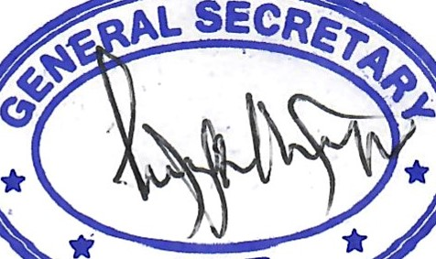

NPP
cotVIM17TEE
Polling Time
44. The poll will start at 7:00 am and close at 2:00 pm at each centero
Polling Agents
45.Each contestants will have Two (2) Accredited Agents but One (l ) Polling Agent at each Polling Station would represent a contestant at all times.
46.Counting & Declaration of Results:
- Ballots will be counted and results announced immediately after the close of poll at each Voting Center.
- The Presiding Officer at the Voting Center will announce the voting center results and a copy of the results forwarded to the Presidential Elections Committee.
- All agents shall sign the declaration form.
- Failure of an Agent to sign the Results will not invalidate the announcement by the Presiding Officer.
- The presiding officer at the voting center shall transmit the constituency results to the EC Headquarters for collation.

Collation of NPP Presidential Primaries at Eiectoral Commission Head Office
47. The results of the Presidential Elections from each Constituency shall be collated first at the Electoral Commission Regional Head Offices
48.Each contestant would EITHER be represented by himselfand/or his accredited agents (2 Agents) at the Collation Center at the EC Headqualters.
49.After the collation, the EC shall officially declare the resulzs at the NPP Headquarters, Asylum Down, Accra, Ali contestants are invited to be at the Party Head Office for this purpose
- The Returning Officer and one of the contestant's Agents at the Collation Centre will jointly sign the results.
- Election Officials to be Recruited
    - One Presiding Officer for each Polling Station
    - One Assistant in charge of the Register.
    - One Assistant in charge of Indelible ink
    - One ballot issuer.
    - One queue controller.

coMMITTEE -
This guidelines or regulations is issued this day Wednesday, September 20, 2023 by the Presidential Elections Committee with the cooperation and acceptance by all the duly appointed representatives of the Presidential Candidates.
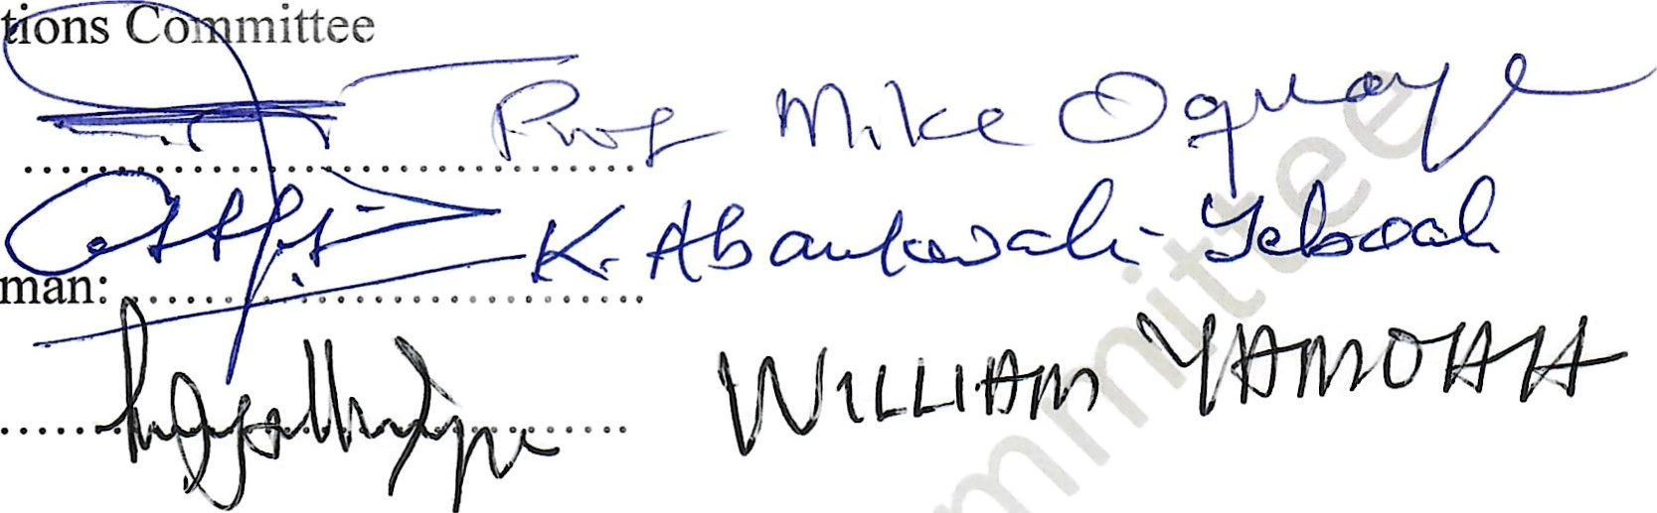
Presidential Elec •ons
  - Chairman:
  - Vice Chairm n:
  - Secretary

Representatives
Name of Candidate Name of Representative Signature
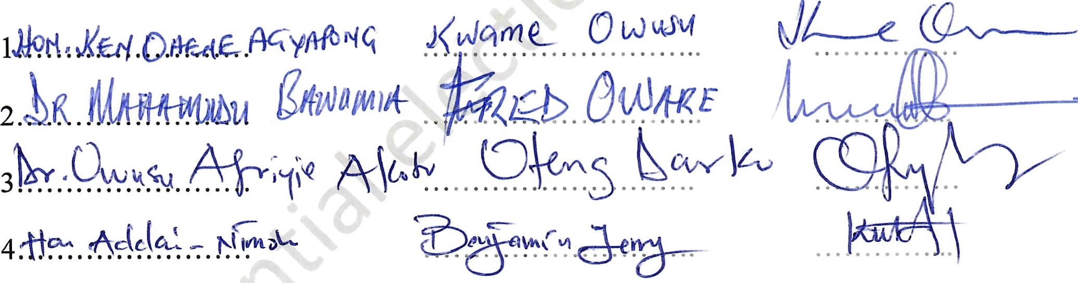UL-—-e

