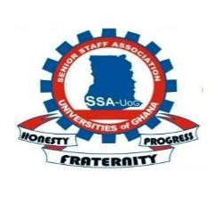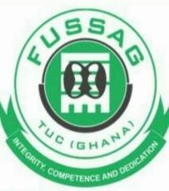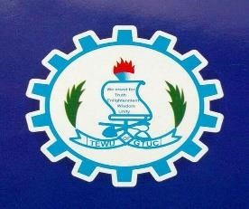

August 5th 2024

FOR IMMEDIATE RELEASE

INTENTION TO EMBARK ON AN INDUSTRIAL ACTION
Greetings to you, our friends of the Media. You will recall that on the 10th of June, 2024,the Senior Staff Association-Universities of Ghana (SSA-UoG), the Federation of Senior Staff Association of Ghana (FUSSAG), the Teachers and Educational Workers Union of Trade Union Congress (TEWU- TUC) gave a notice to the Fair Wages and Salaries Commission of Ghana that we will be forced to take industrial action on the 21st of June, 2024 if the Commission fails to rectify the injustice meted out to our members regarding the Vehicle Maintenance Allowance (VMA) and other related allowances.
The National Labour Commission summoned the parties for a hearing on the issue on the 19th of June, 2024 and directed the parties to go and engage and report on the 26th of June, 2024. The fair Wages and Salaries Commission subsequently invited the unions concerned to discuss the issue. At the end of the day an agreement was reached and an addendum signed (copy attached).
The Fair Wags and Salaries Commission has done the needful by writing to the Ministry for Finance for payment to be effected. We have tried to engage the Ministry on several occasions to release a letter to that effect so our members could be paid but the Ministry has refused. Meanwhile those universities on government Subvention have been paid together with the arrears leaving those directly on the Controller and Account General’s Payroll.
Now the Ghana Tertiary Education Commission is ordering the universities not to pay the new rate until a letter from the Ministry authorizing the payment is released. In that case even those who are receiving the new rate are going to be denied the new rate while those who are on the Controller payroll still remain at where they are.
The Unions believe that government is using Machiavellian tactics to deny us of an agreement reached with them.
The Unions have giving the government (Ministry) up to the close of work on Thursday 8th August to release the letter.
Failure to do so will result in the Unions being forced to take industrial action on the 9th of August, 2024.
The SSA-UoG, FUSSAG and TEWU (TUC) are committed to fighting for the rights of its members and will not rest until justice is served.
Thank you.
Signed:

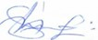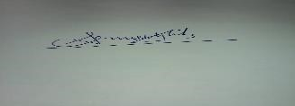
George Ansong Ken Puotiere Yelibo
National Chairman National Chairman
SSA-UoG FUSSAG
(0243722694) (0208127575)
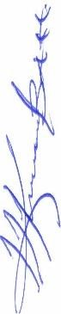
King James Azortibah
General Secretary
TEWU (TUC)

